

|  |
| --- |
| Mahmoud Abou Zither4/27/2022 Problem-Solved  Zep task |
|  |

|  |  |  |
| --- | --- | --- |
| Cars dataset | |  |
| First:  * import the libs I will use * use pandas to read the data * use parse dates and convert the column to date time data type |  | |
| * use head/tail to see how the data looks like | | |
| Page 2 | | |

* we first use the slat ,slon,elat and elon to get the distance between to point
* and I use the truck id to know the full trip of each car
* and add the distance of the point with each other based on this id to find the full trip distance

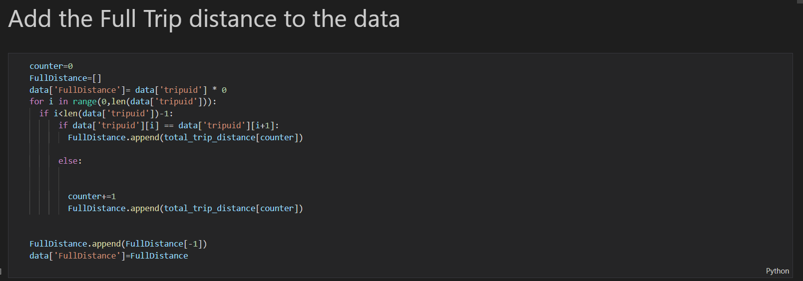

* then I put the full distance in the main data set as a new feature

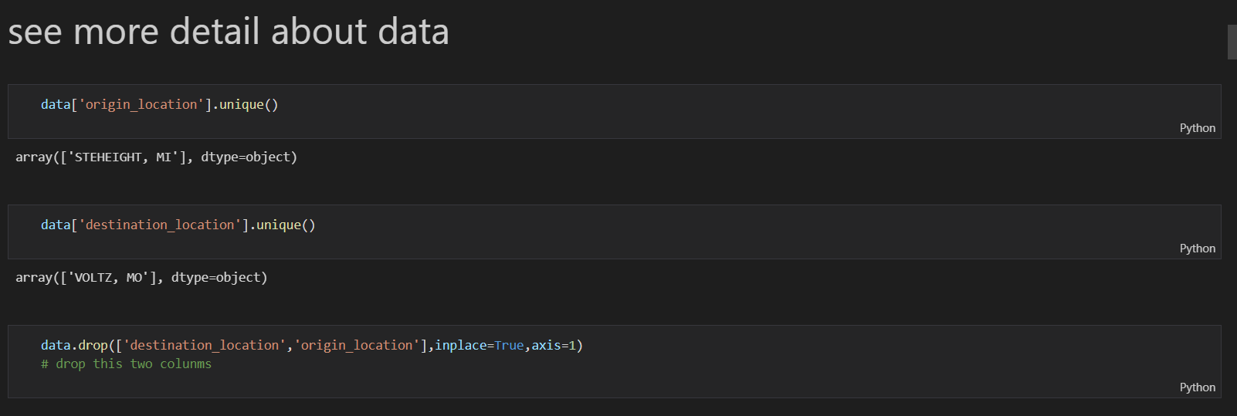

* research the data to find new information I see that this 2 cols in one value cols so I drop them

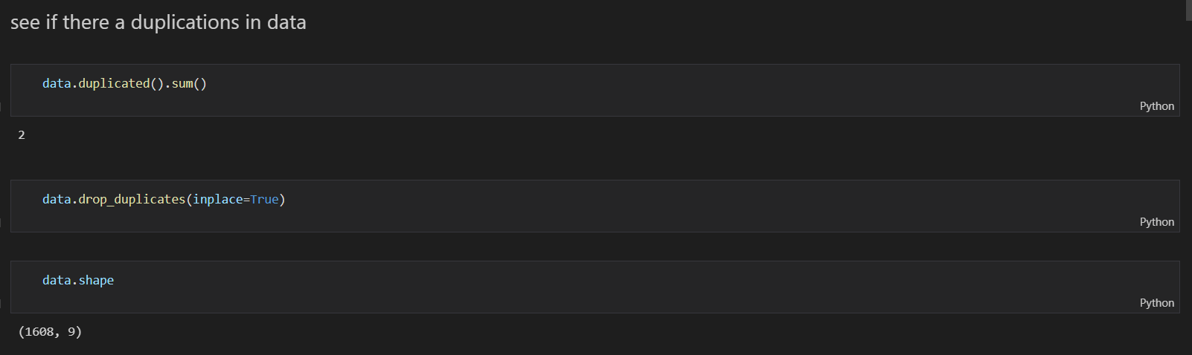

* see the duplication and drop it

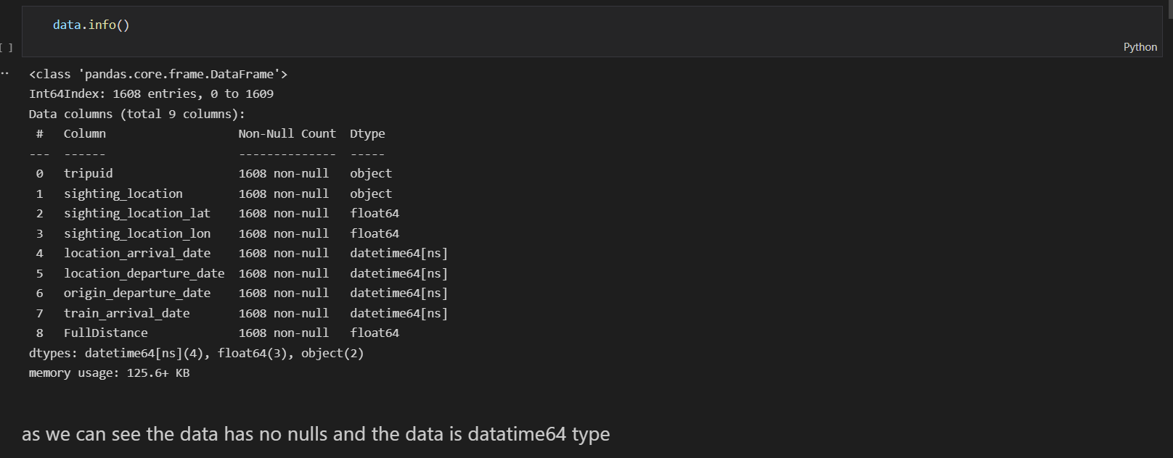

* data info to know is there any nulls and to know the data type of each feature

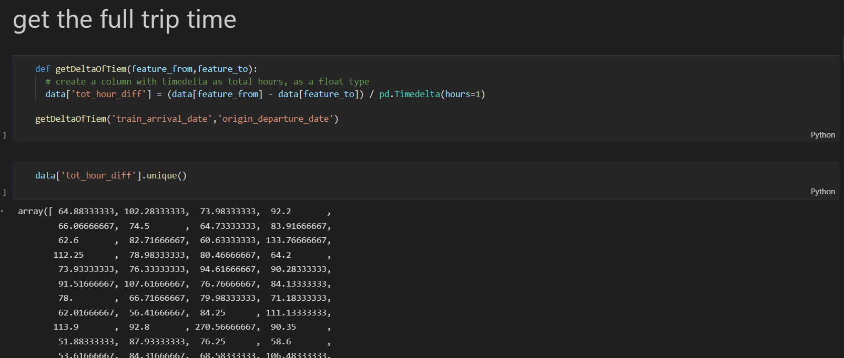

* is function to get the total time of all the trips

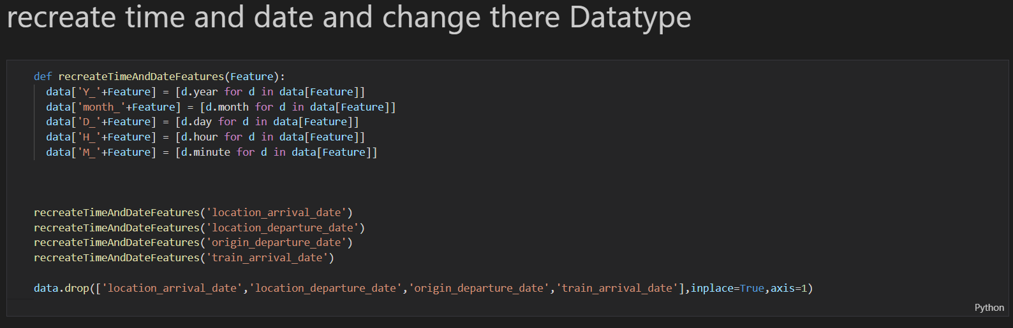

* here function to reshape the date time data type to float and int to work with them in the model

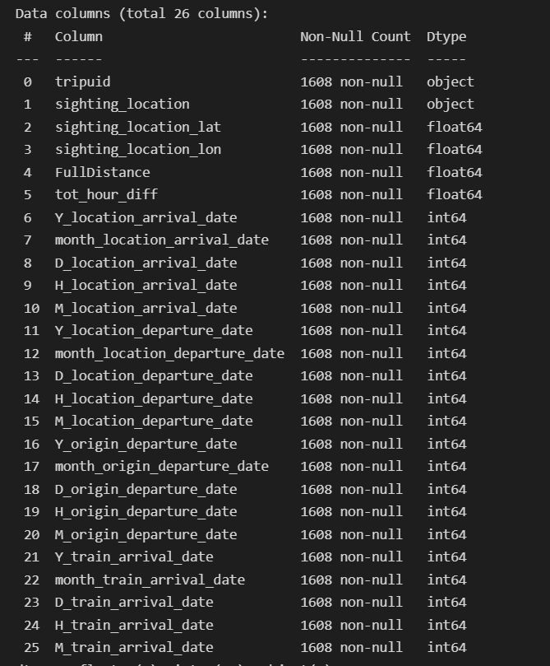

* the new info of the data

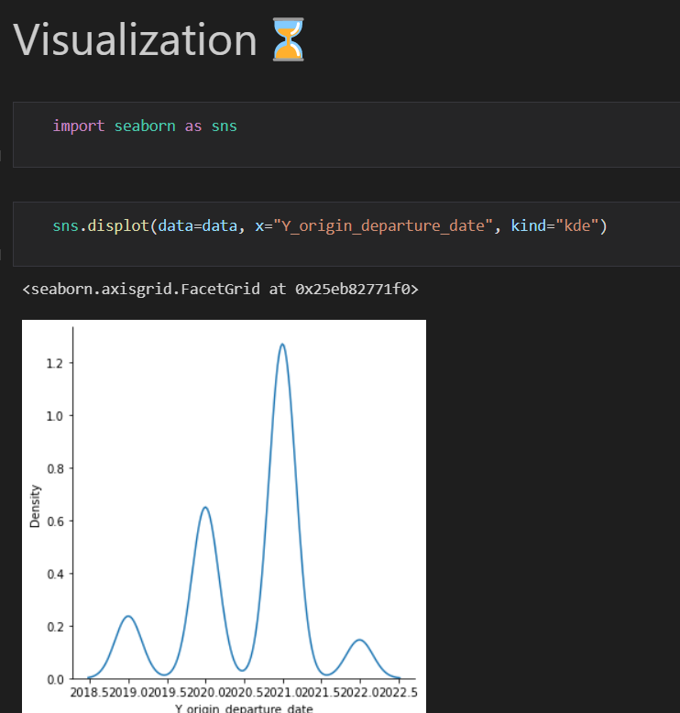

* here in the part of the visualization we use seaborn
* first we see in this plot that the most year with work was 2021

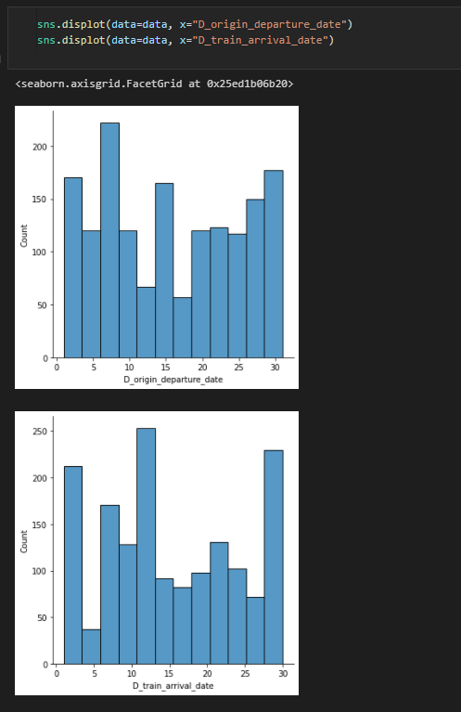

* to see if there is a relation between the data of arrive and day of departure
* but I found that busy days are in the start and the end of the month



* and here we can see this much clearly

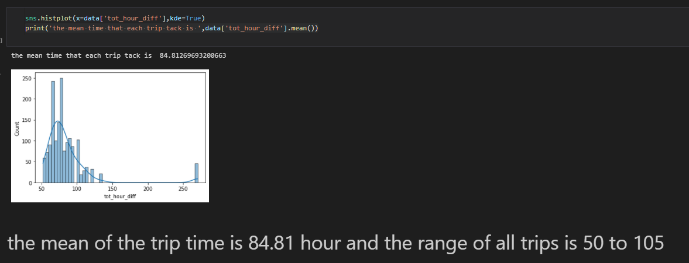

* the distribution of the full trip time and know the range of almost all the trips

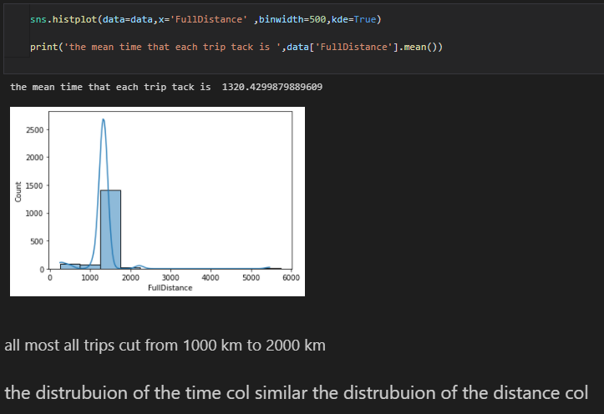

* here is the distribution of the distance and it looks similar to the distribution of the full trip time
* which make sense

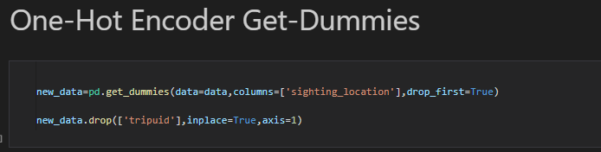 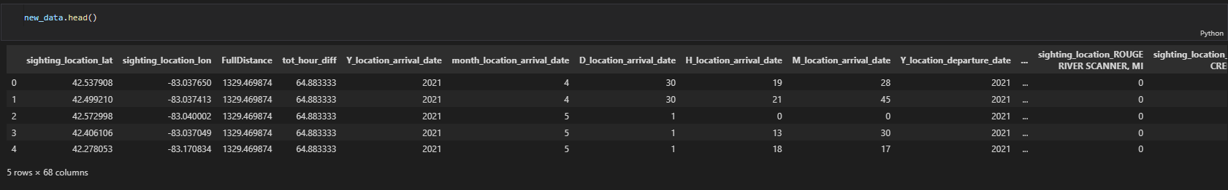

* one –hot encoder to the only feature which is object and make the data ready to train

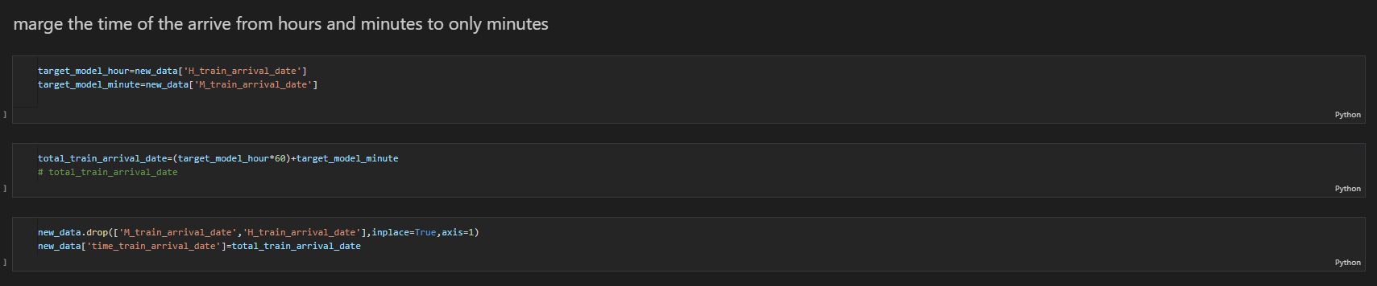

* we have to predict time so we take the hour of arrive and covert it to minutes
* then add it to the minutes to get the whole time in minutes which we can predict at this case



* split the data to train and test to make sure that the model train the data without any overfitting or underfitting

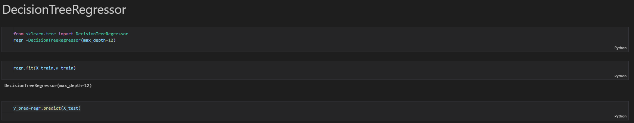

* I use the decision tree because the data has high variance and the weak correlation between features and each other’s

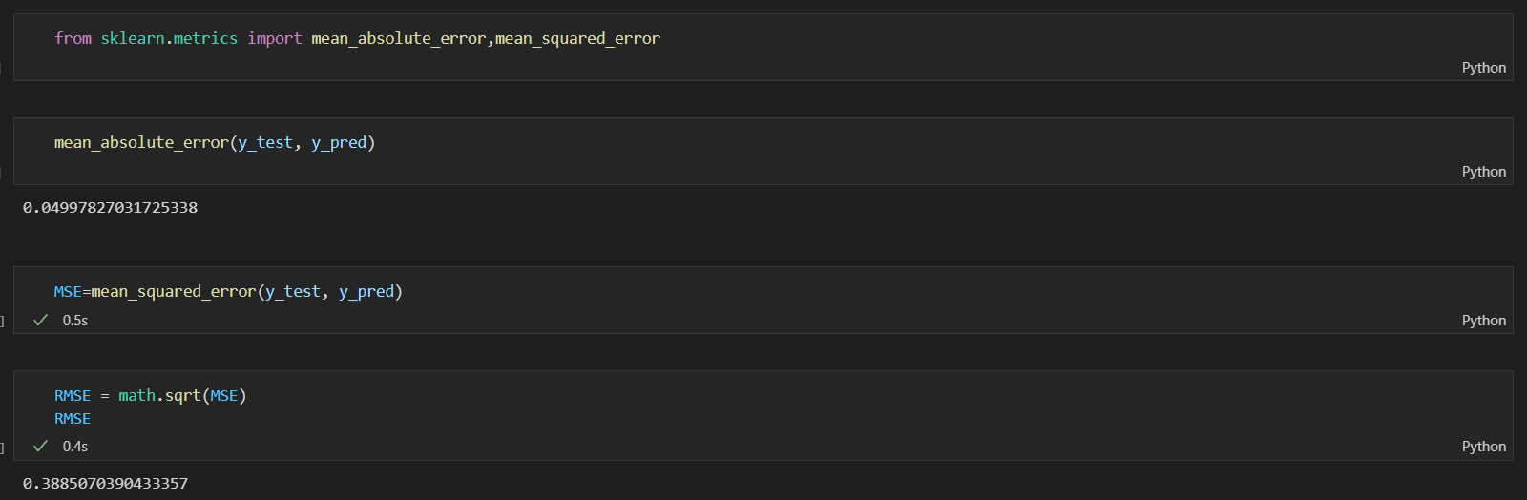

* We use the MAE and the RMSE I get MAE=0,0499 and RMSE =0.388

# Contact

* You will find my links in the end of the Jupiter note book
* My github link: <https://github.com/abou-zithar>
* My linked in link: https://www.linkedin.com/in/abou-zithar/
* Gmail: mahmoudabouzit@gmail.com



# At the end

Thank you for this opportunity to work on this dataset and I hope that I complete the objectives